

International School

**Capstone Project 2**

CMU-SE 451

**User Interface**

Version 1.3

Date: 15 Apr 2021

**SENIOR PROJECT MANAGEMENT SYSTEM**

**FOR INTERNATIONAL SCHOOL**

**Submitted by**

Tien, Nguyen Van

Phuoc, Ha Duc

Huy, Truong Dong

Dat, Nguyen Thanh

**Approved by**

Chau, Truong Ngoc

**Proposal Review Panel Representative:**

Name Signature Date

**Capstone Project 2- Mentor:**

Name Signature Date

**PROJECT INFORMATION**

|  |  |  |  |  |  |
| --- | --- | --- | --- | --- | --- |
| **Project acronym** | Senior Project Management System for International School | | | | |
| **Project Title** | SPMS | | | | |
| **Start Date** | 18 Feb 2022 | | **End Date** | 15 May 2022 | |
| **Lead Institution** | International School, Duy Tan University | | | | |
| **Project Mentor** | Chau, Truong Ngoc | | | | |
| **Scrum master / Project Leader & contact details** | Tien, Nguyen Van  Email: cnnguyenvantien@gmail.com  Tel: 0704.042.832  Student ID: 24211208536 | | | | |
| **Partner Organization** |  | | | | |
| **Project Web URL** |  | | | | |
| **Team members** | **Name** | **Email** | | | **Tel** |
| 24211202634 | Phuoc, Ha Duc | dphuoc432000@gmail.com | | | 0961622464 |
| 24211206538 | Huy, Truong Dong | huydongtruong@gmail.com | | | 0358040650 |
| 24211206470 | Dat, Nguyen Thanh | ngthanhdat521@gmail.com | | | 0767836541 |

**REVISION HISTORY**

| **Version** | **Date** | **Comments** | **Author** | **Approval** |
| --- | --- | --- | --- | --- |
| v1.0 | 18/02/2022 | Initial Release | All Members | x |
| v1.1 | 18/02/2022 | Update document | Dat | x |
| v1.2 | 11/03/2022 | Update document | Dat | x |
| v1.3 | 15/04/2022 | Format document | Dat | x |

Table of Contents

1. Introduction 8

1.1. Purpose of document 8

1.2. Project goal 8

2. Describe user interface in the system 8

2.1. Login 8

2.2. Register 9

2.3. About 10

2.4. Introduction 11

2.5. Moderator’s notification 12

2.6. Notification 13

2.7. Stage board 14

2.8. Task management 15

2.9. My topic 16

2.10. Topic template 17

2.11. Document template 18

2.12. My group 19

2.13. Group list 20

2.14. Lecturer’s profile 21

2.15. Lecturer management 22

2.16. Student management 23

2.17. Topic approval 24

2.18. Group management 25

2.19. Document management 26

2.20. Topic management 27

2.21. Contribution report 28

Table of Figure

**Figure 2.1:** *Login.* 8

**Figure 2.2:** *Register.* 9

**Figure 2.3:** *About.* 10

**Figure 2.4:** *Introduction.* 11

**Figure 2.5:** *Moderator’s notification.* 12

**Figure 2.6:** *Notification.* 13

**Figure 2.7:** *Stage board.* 14

**Figure 2.8:** *Task management.* 15

**Figure 2.9:** *My topic.* 16

**Figure 2.10:** *Topic template.* 17

**Figure 2.11:** *Document template.* 18

**Figure 2.12:** *My group.* 19

**Figure 2.13:** *Group list.* 20

**Figure 2.14:** *Lecturer’s profile.* 21

**Figure 2.15:** *Lecturer management.* 22

**Figure 2.16:** *Student management.* 23

**Figure 2.17:** *Topic approval.* 24

**Figure 2.18:** *Group management.* 25

**Figure 2.19:** *Document management.* 26

**Figure 2.20:** *Topic management.* 27

**Figure 2.21:** *Contribution report.* 28

Table of Tables

**Table 2.1:** *Login description.* 8

**Table 2.2:** *Register description.* 9

**Table 2.3:** *About description.* 10

**Table 2.5:** *Moderator’s notification description.* 12

**Table 2.6:** *Notification description.* 13

**Table 2.7:** *Stage board description.* 14

**Table 2.8:** *Task management description.* 15

**Table 2.9:** *My topic description.* 16

**Table 2.10:** *Topic template document.* 17

**Table 2.11:** *Document template description.* 18

**Table 2.13:** *Group list description.* 20

**Table 2.14:** *Lecturer’s profile description.* 21

**Table 2.15:** *Lecturer management description.* 22

**Table 2.16:** *Student management description.* 23

**Table 2.17:** *Topic approval description.* 24

**Table 2.18:** *Group management description.* 25

**Table 2.19:** *Document management description.* 26

**Table 2.20:** *Topic management description.* 27

**SIGNATURE**

**Document Approvals:** *The following signatures are required for approval of this document.*

|  |  |  |
| --- | --- | --- |
| Chau, Truong Ngoc  *Mentor* |  | Date: |
| Tien, Nguyen Van  *Scrum Master* |  | Date: |
| Phuoc, Ha Duc  *Product Owner* |  | Date: |
| Huy, Truong Dong  *Member* |  | Date: |
| Dat, Nguyen Thanh  *Member* |  | Date: |

1. **Introduction**
   1. **Purpose of document**

This document serves the purpose of specifying application’s UI design

* 1. **Project goal**
* Create complete interfaces, and describe them clearly.
* Overview of the stages and modules of the system.

1. **Describe user interface in the system**
   1. **Login**

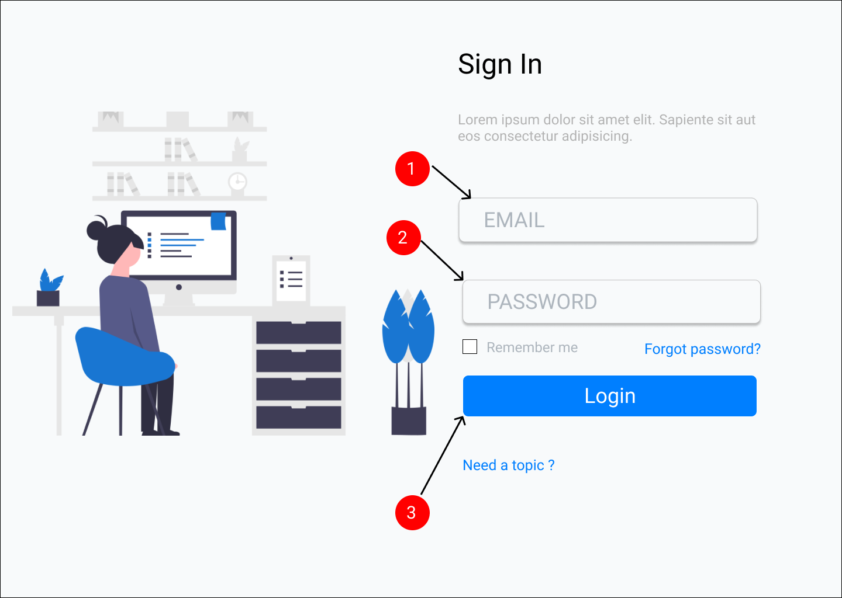

**Figure 2.1:** *Login.*

**Table 2.1:** *Login description.*

|  |  |  |  |
| --- | --- | --- | --- |
| **ID** | **Condition** | **Control Type** | **Target** |
| 1 | Type | Textbox | Type an email |
| 2 | Type | Textbox | Type a password |
| 3 | Click | Button | Click to login into the system |

* 1. **Register**

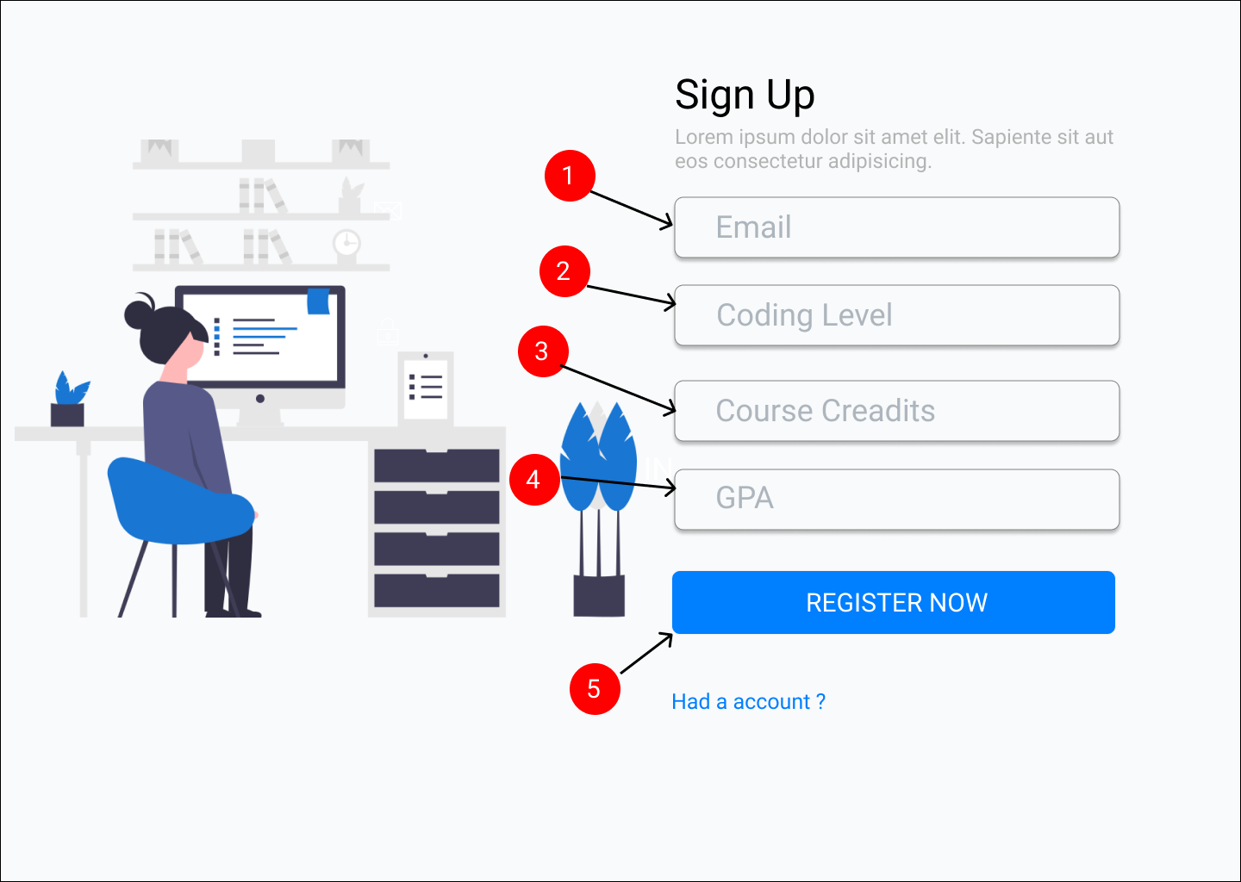

**Figure 2.2:** *Register.*

**Table 2.2:** *Register description.*

|  |  |  |  |
| --- | --- | --- | --- |
| **ID** | **Condition** | **Control Type** | **Target** |
| 1 | Type | Textbox | Type an email |
| 2 | Type | Textbox | Type a coding level |
| 3 | Type | Textbox | Type a course credit |
| 4 | Type | Textbox | Type a gpa |
| 5 | Click | Button | Click to register into the system |

* 1. **About**

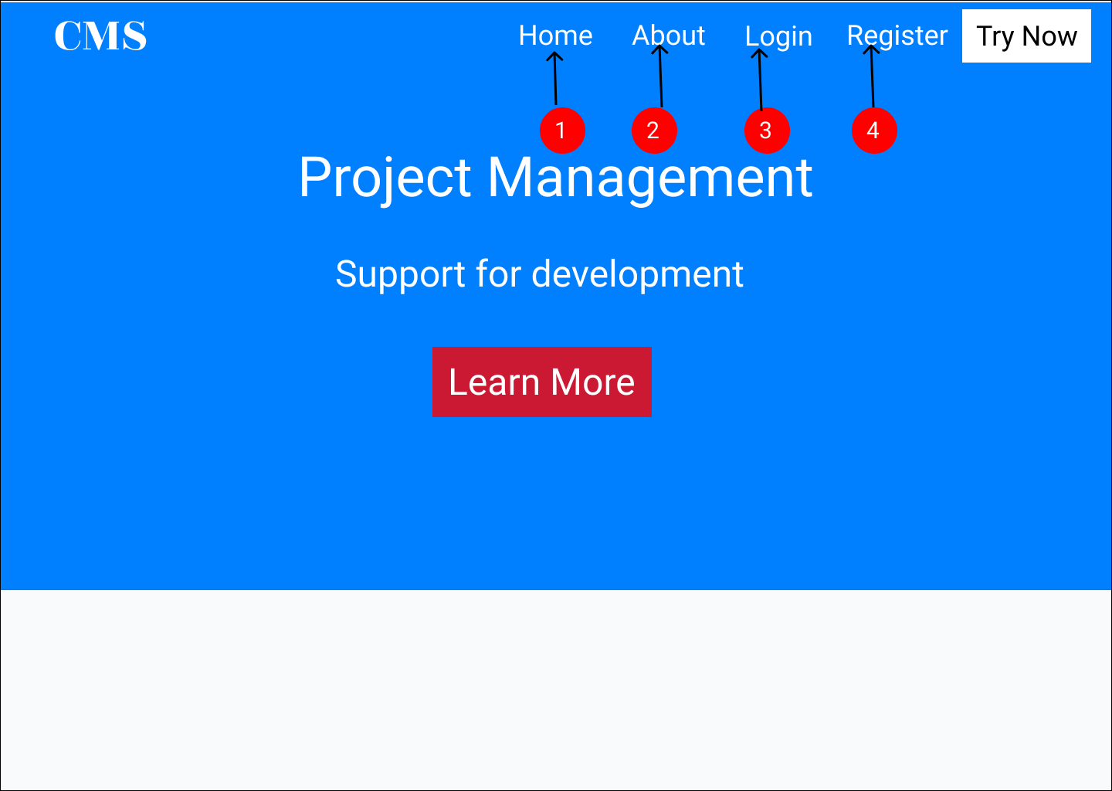

**Figure 2.3:** *About.*

**Table 2.3:** *About description.*

|  |  |  |  |
| --- | --- | --- | --- |
| **ID** | **Condition** | **Control Type** | **Target** |
| 1 | Click | Link | Redirect to home page |
| 2 | Click | Link | Redirect to about page |
| 3 | Click | Link | Redirect to login page |
| 4 | Click | Link | Redirect to register page |

* 1. **Introduction**

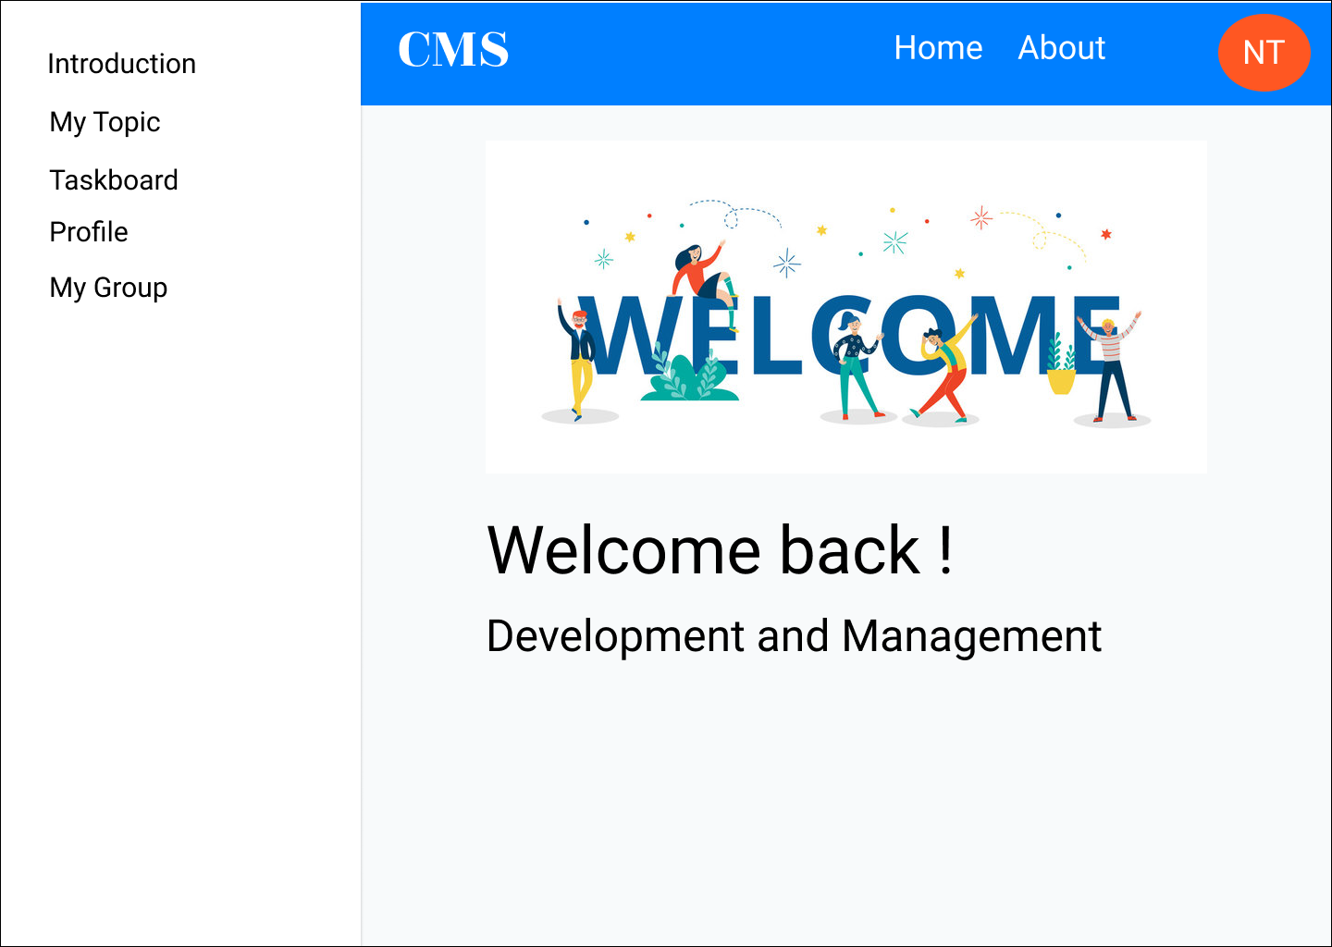

**Figure 2.4:** *Introduction.*

* 1. **Moderator’s notification**

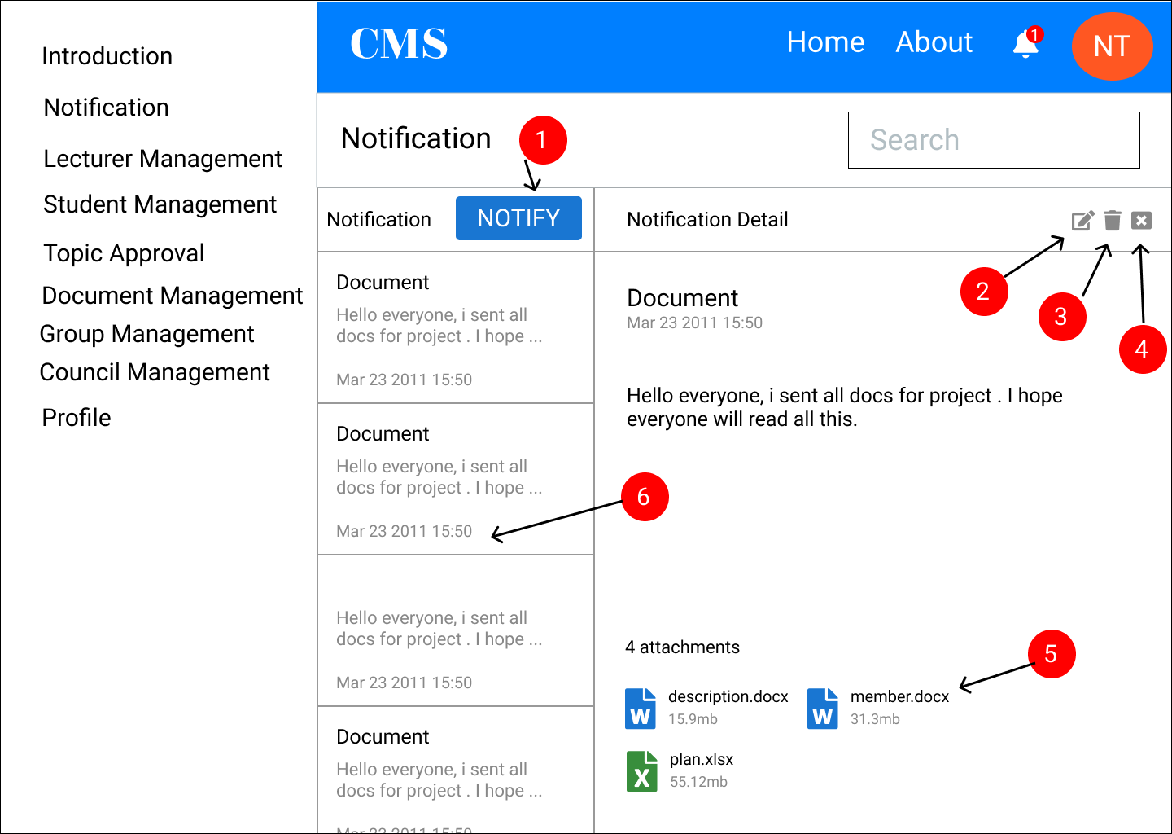

**Figure 2.5:** *Moderator’s notification.*

**Table 2.5:** *Moderator’s notification description.*

|  |  |  |  |
| --- | --- | --- | --- |
| **ID** | **Condition** | **Control Type** | **Target** |
| 1 | Click | Button | Add a notification |
| 2 | Click | Button | Edit notification |
| 3 | Click | Button | Delete notification |
| 4 | Click | Button | Close notification |
| 5 | Click | Text | Download file |
| 6 | Click | Button | Open a detail notification |

* 1. **Notification**

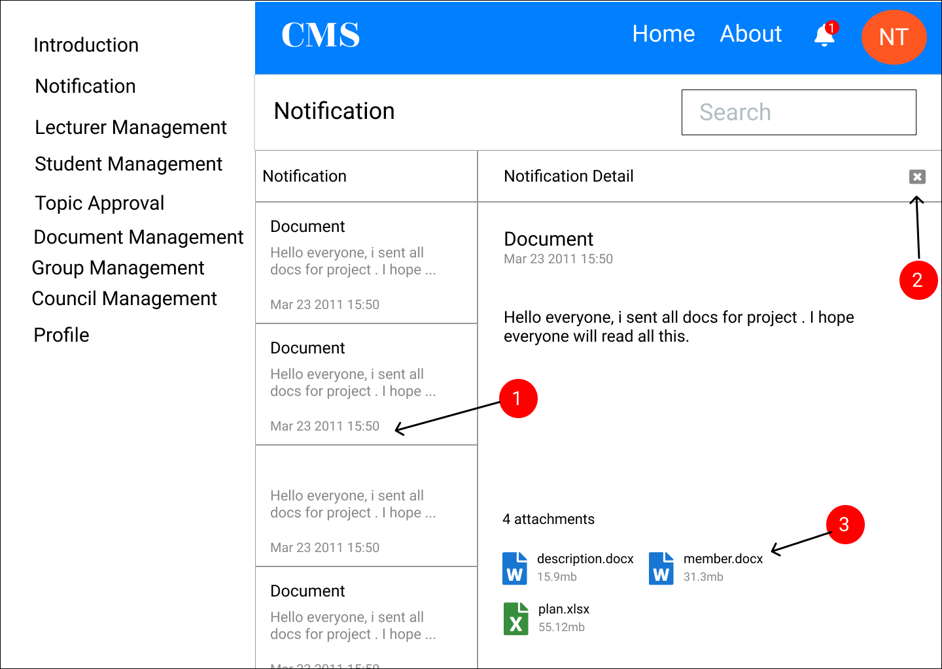

**Figure 2.6:** *Notification.*

**Table 2.6:** *Notification description.*

|  |  |  |  |
| --- | --- | --- | --- |
| **ID** | **Condition** | **Control Type** | **Target** |
| 1 | Click | Button | Open a detail notification |
| 2 | Click | Icon | Close notification |
| 3 | Click | Button | Download notification |

* 1. **Stage board**

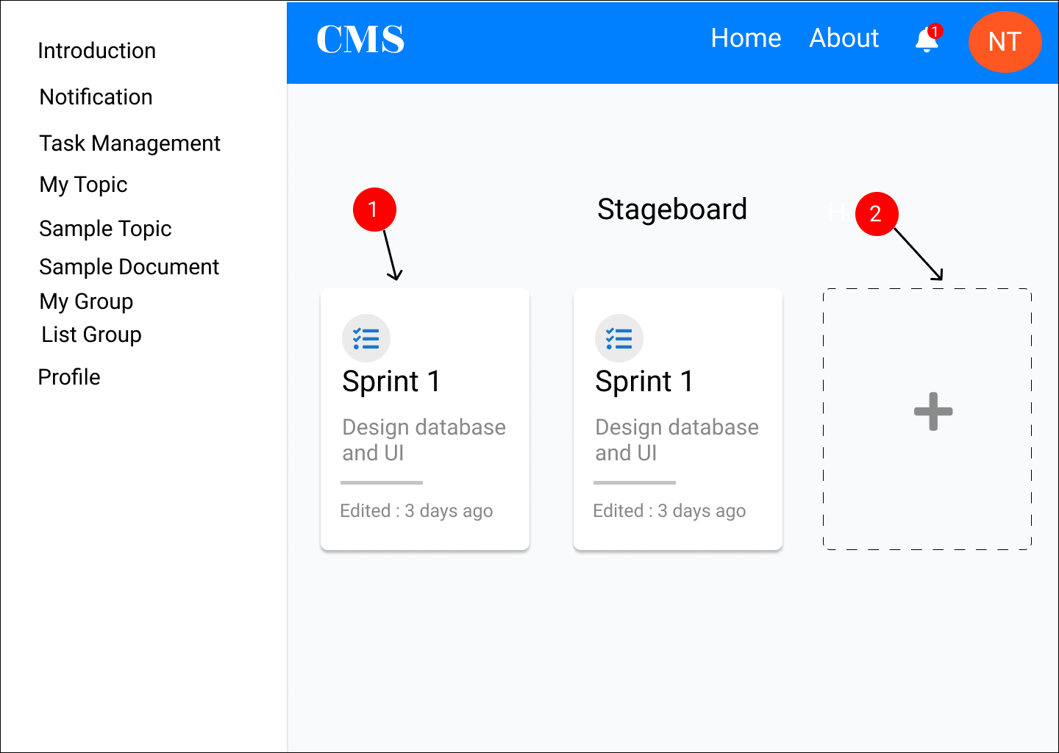

**Figure 2.7:** *Stage board.*

**Table 2.7:** *Stage board description.*

|  |  |  |  |
| --- | --- | --- | --- |
| **ID** | **Condition** | **Control Type** | **Target** |
| 1 | Click | Link | Redirect a task management page |
| 2 | Click | Button | Add a stage |

* 1. **Task management**

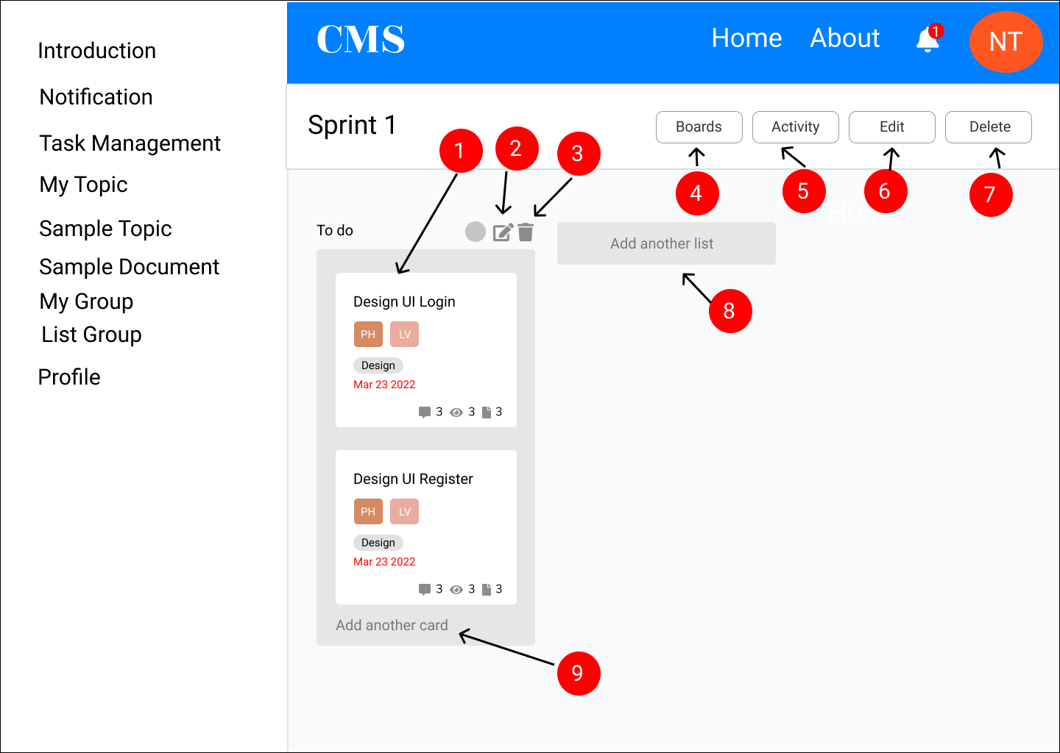

**Figure 2.8:** *Task management.*

**Table 2.8:** *Task management description.*

|  |  |  |  |
| --- | --- | --- | --- |
| **ID** | **Condition** | **Control Type** | **Target** |
| 1 | Click | Button | Open a task |
| 2 | Click | Icon | Edit list |
| 3 | Click | Icon | Delete list |
| 4 | Click | Button | Redirect the stage board page |
| 5 | Click | Button | Show activity |
| 6 | Click | Button | Edit stage |
| 7 | Click | Button | Delete stage |
| 8 | Click | Button | Add list |
| 9 | Click | Button | Add task |

* 1. **My topic**

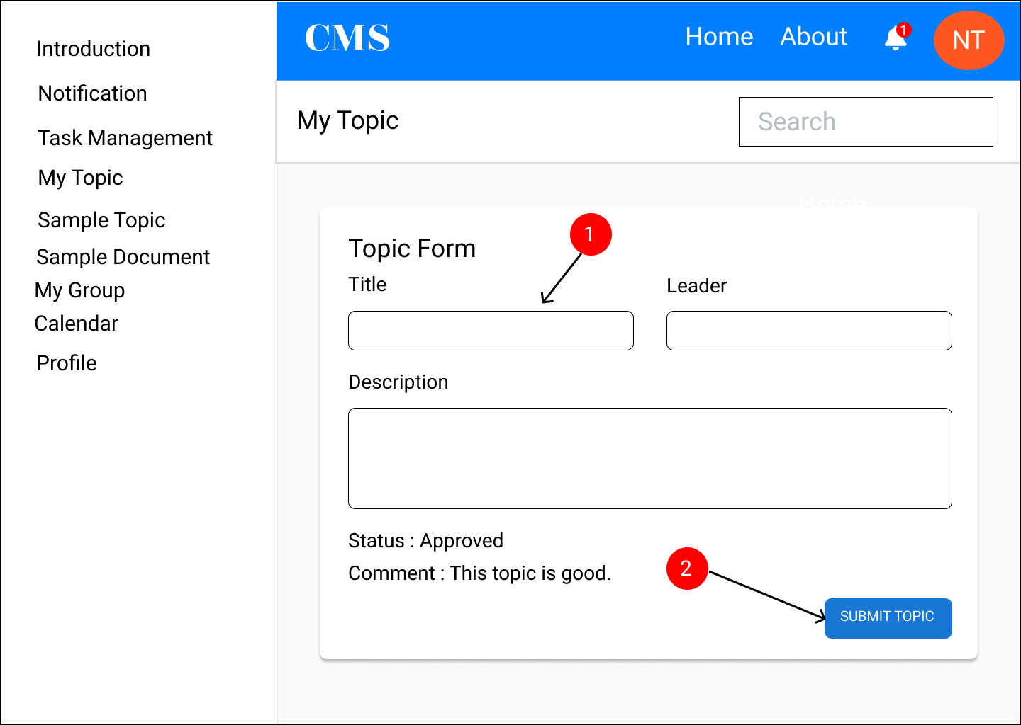

**Figure 2.9:** *My topic.*

**Table 2.9:** *My topic description.*

|  |  |  |  |
| --- | --- | --- | --- |
| **ID** | **Condition** | **Control Type** | **Target** |
| 1 | Type | Textbox | Enter a fields |
| 2 | Click | Button | Submit a topic for student |

* 1. **Topic template**

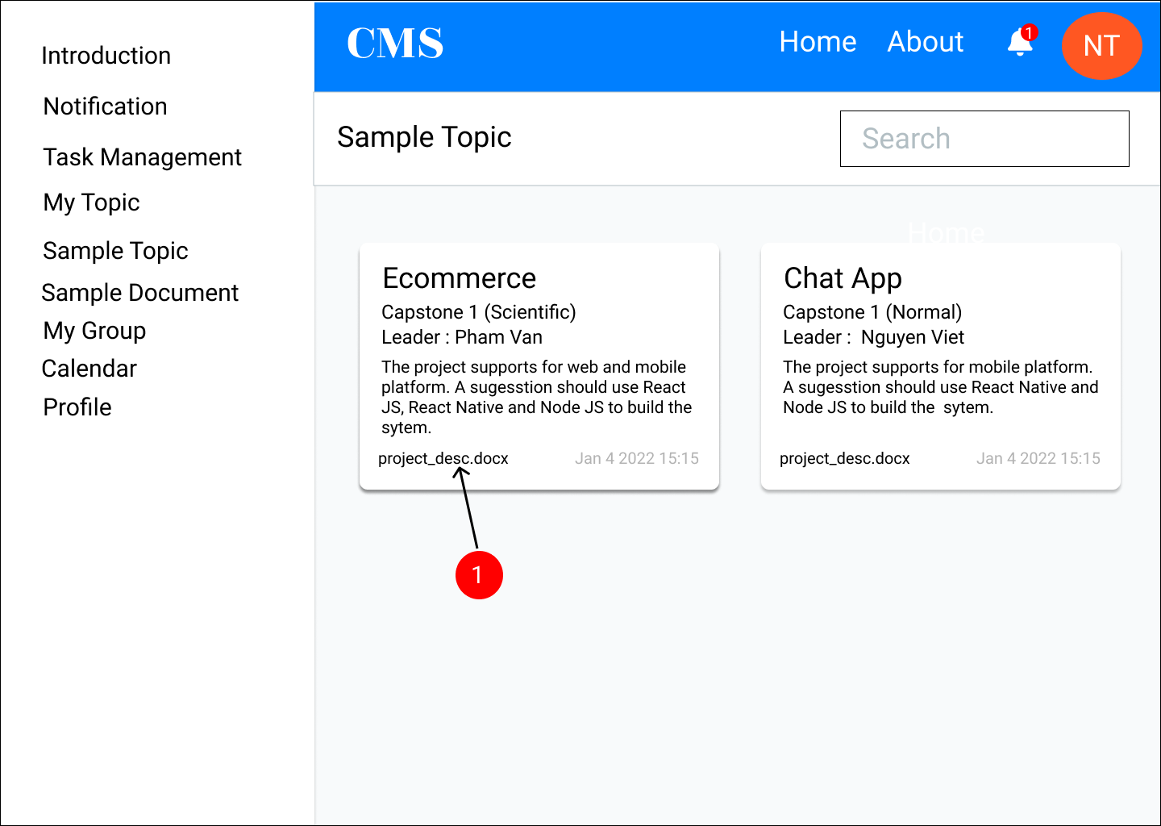

**Figure 2.10:** *Topic template.*

**Table 2.10:** *Topic template document.*

|  |  |  |  |
| --- | --- | --- | --- |
| **ID** | **Condition** | **Control Type** | **Target** |
| 1 | Click | Link | Download a description file |

* 1. **Document template**

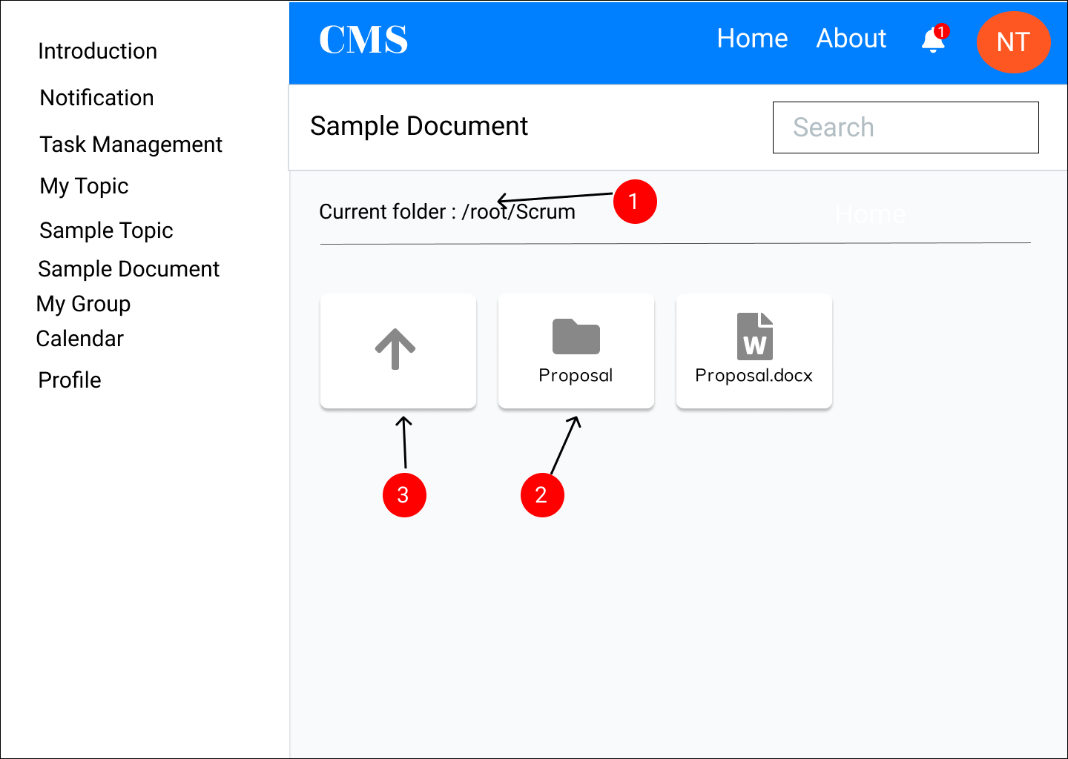

**Figure 2.11:** *Document template.*

**Table 2.11:** *Document template description.*

|  |  |  |  |
| --- | --- | --- | --- |
| **ID** | **Condition** | **Control Type** | **Target** |
| 1 | Click | Text | Change directory |
| 2 | Click | Button | Click to move to folder |
| 3 | Click | Button | Click to back a old folder |

* 1. **My group**

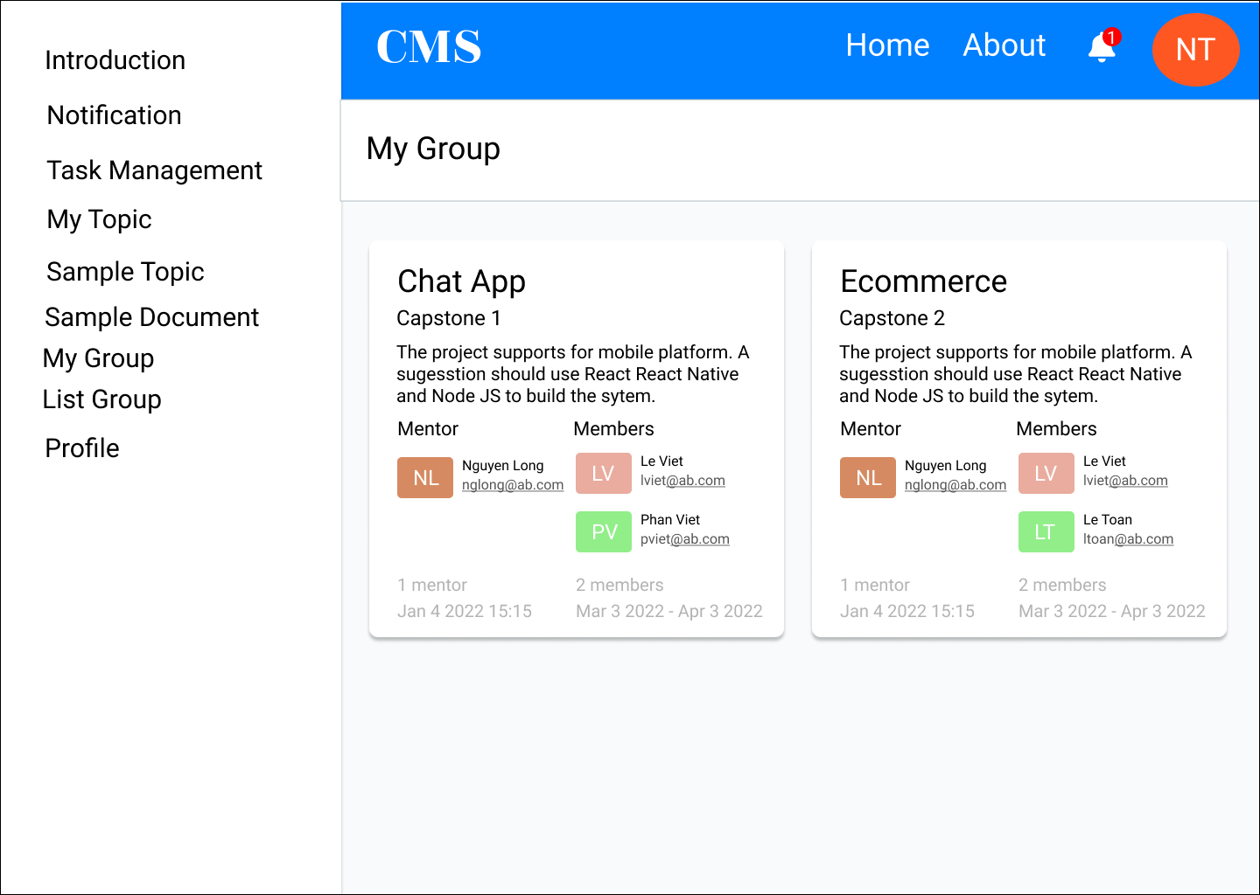

**Figure 2.12:** *My group.*

* 1. **Group list**

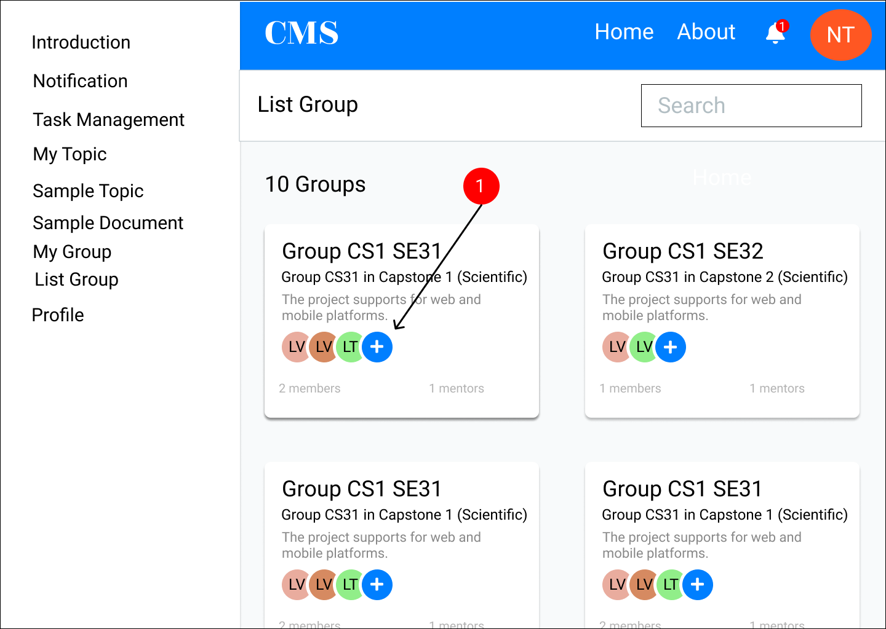

**Figure 2.13:** *Group list.*

**Table 2.13:** *Group list description.*

|  |  |  |  |
| --- | --- | --- | --- |
| **ID** | **Condition** | **Control Type** | **Target** |
| 1 | Click | Button | Click to open a list of detail info of members |

* 1. **Lecturer’s profile**

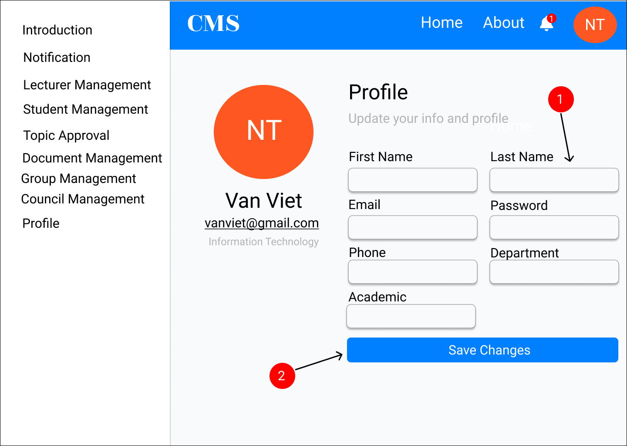

**Figure 2.14:** *Lecturer’s profile.*

**Table 2.14:** *Lecturer’s profile description.*

|  |  |  |  |
| --- | --- | --- | --- |
| **ID** | **Condition** | **Control Type** | **Target** |
| 1 | Type | Textbox | Type a field |
| 2 | Click | Button | Click to save changes from the profile |

* 1. **Lecturer management**

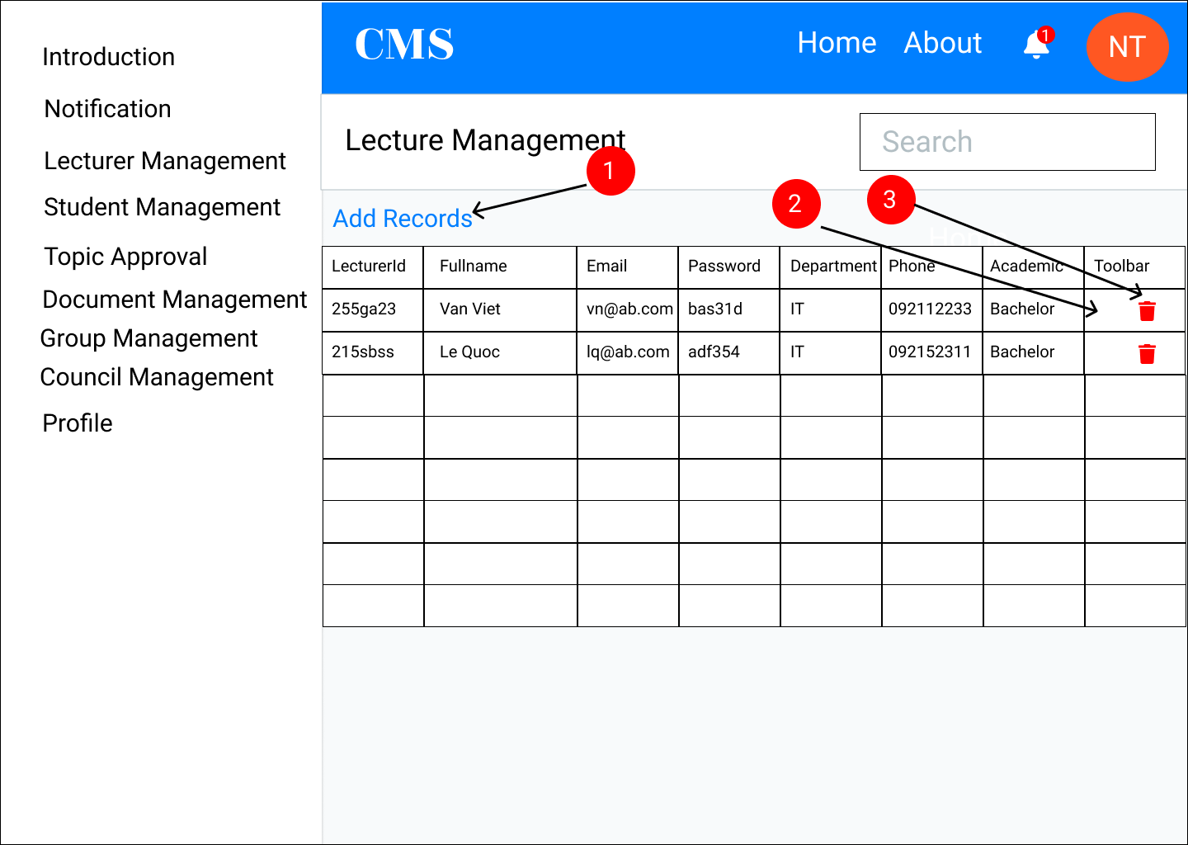

**Figure 2.15:** *Lecturer management.*

**Table 2.15:** *Lecturer management description.*

|  |  |  |  |
| --- | --- | --- | --- |
| **ID** | **Condition** | **Control Type** | **Target** |
| 1 | Click | Button | Open a form to add records |
| 2 | Click | Button | Edit the current row |
| 3 | Click | Button | Delete the current row |

* 1. **Student management**

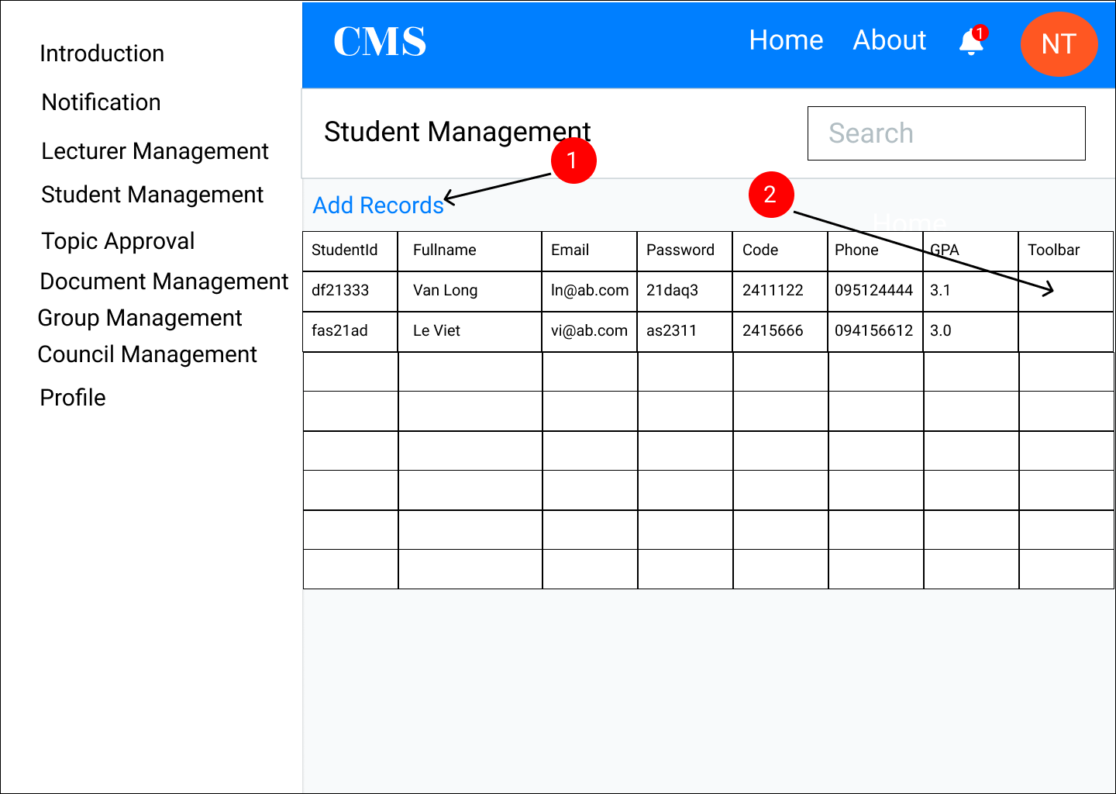

**Figure 2.16:** *Student management.*

**Table 2.16:** *Student management description.*

|  |  |  |  |
| --- | --- | --- | --- |
| **ID** | **Condition** | **Control Type** | **Target** |
| 1 | Click | Button | Open a form to add records |
| 2 | Click | Button | Approve this student |

* 1. **Topic approval**

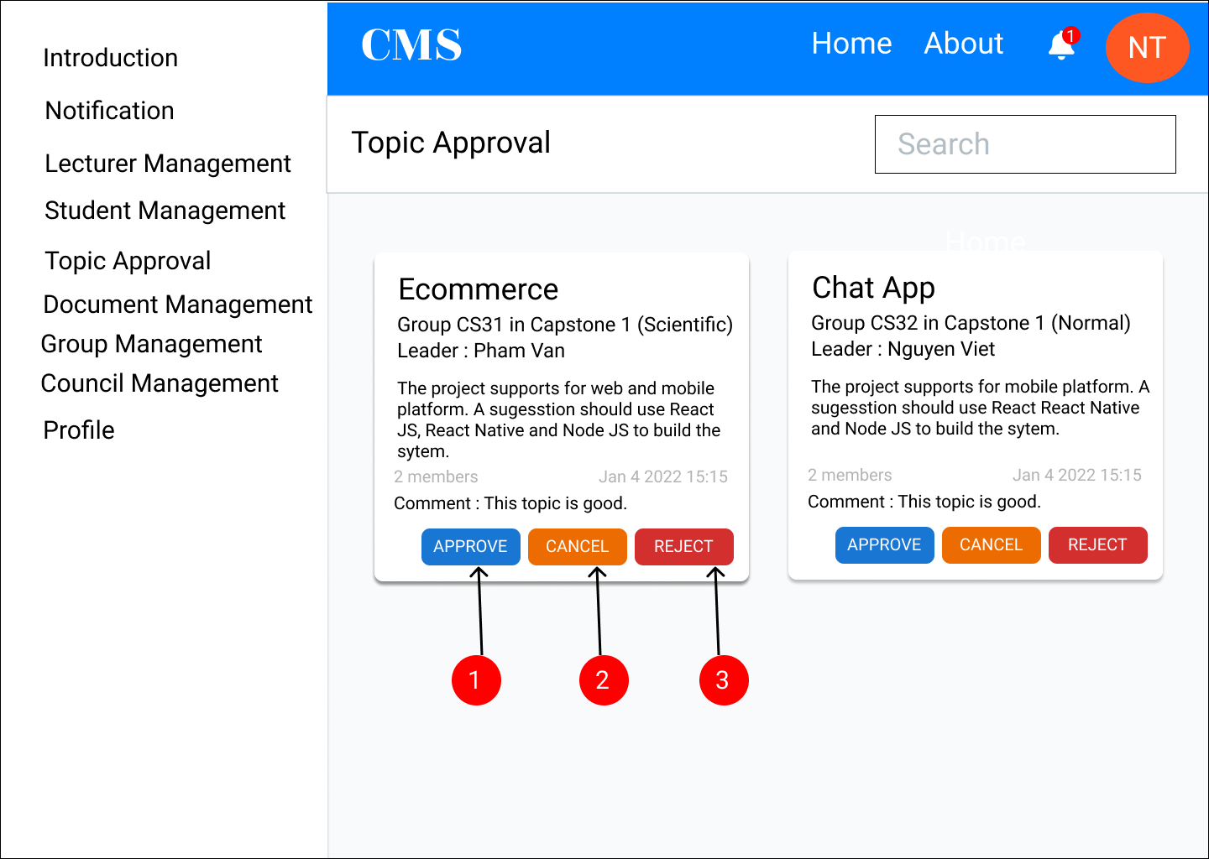

**Figure 2.17:** *Topic approval.*

**Table 2.17:** *Topic approval description.*

|  |  |  |  |
| --- | --- | --- | --- |
| **ID** | **Condition** | **Control Type** | **Target** |
| 1 | Click | Button | Approve this topic |
| 2 | Click | Button | Cancel this topic |
| 3 | Click | Button | Reject this topic |

* 1. **Group management**

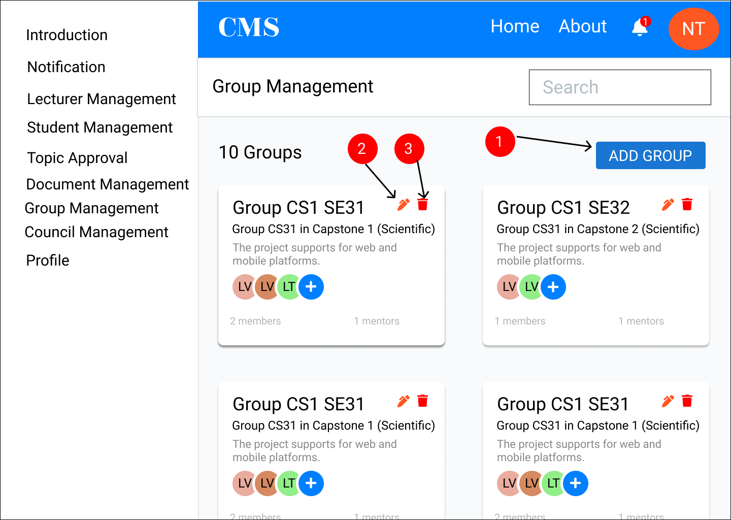

**Figure 2.18:** *Group management.*

**Table 2.18:** *Group management description.*

|  |  |  |  |
| --- | --- | --- | --- |
| **ID** | **Condition** | **Control Type** | **Target** |
| 1 | Click | Button | Add a new group |
| 2 | Click | Button | Edit group |
| 3 | Click | Button | Delete group |

* 1. **Document management**

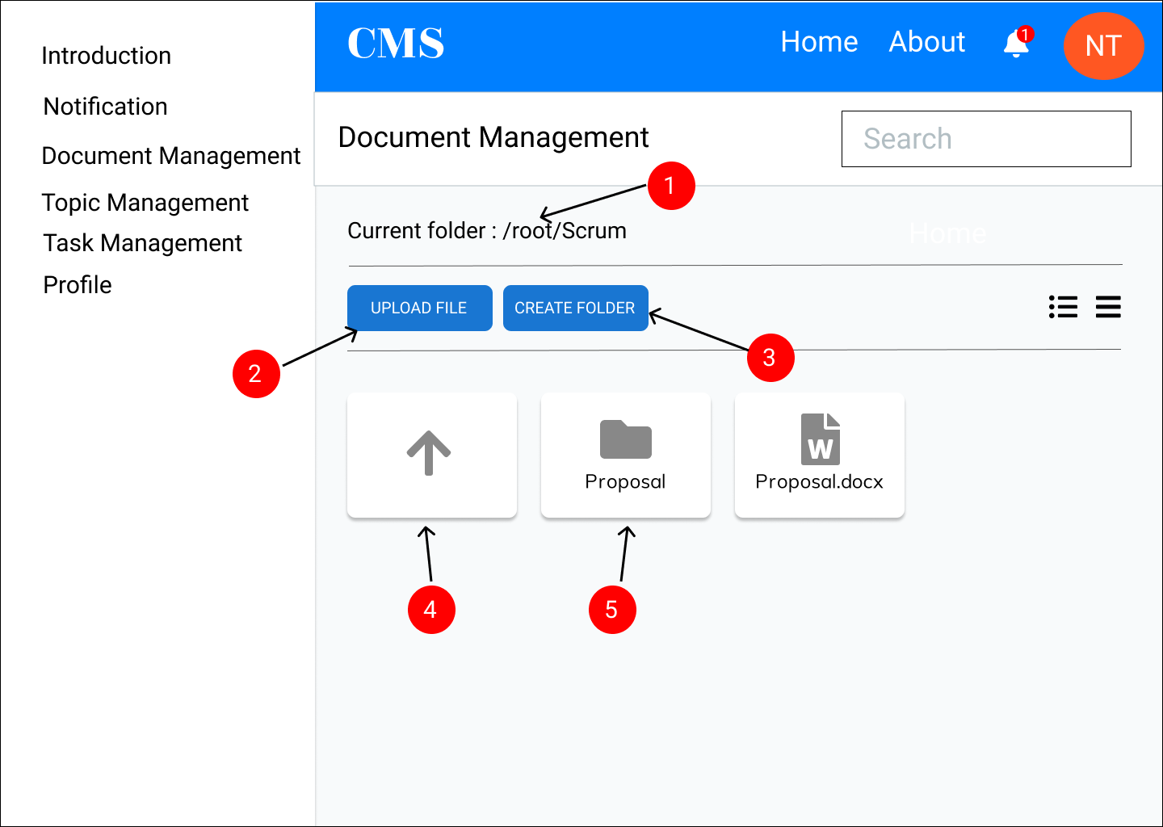

**Figure 2.19:** *Document management.*

**Table 2.19:** *Document management description.*

|  |  |  |  |
| --- | --- | --- | --- |
| **ID** | **Condition** | **Control Type** | **Target** |
| 1 | Click | Text | Change directory |
| 2 | Click | Button | Upload a file |
| 3 | Click | Button | Create a folder |
| 4 | Click | Button | Back a old folder |
| 5 | Click | Button | Move to a folder |

* 1. **Topic management**

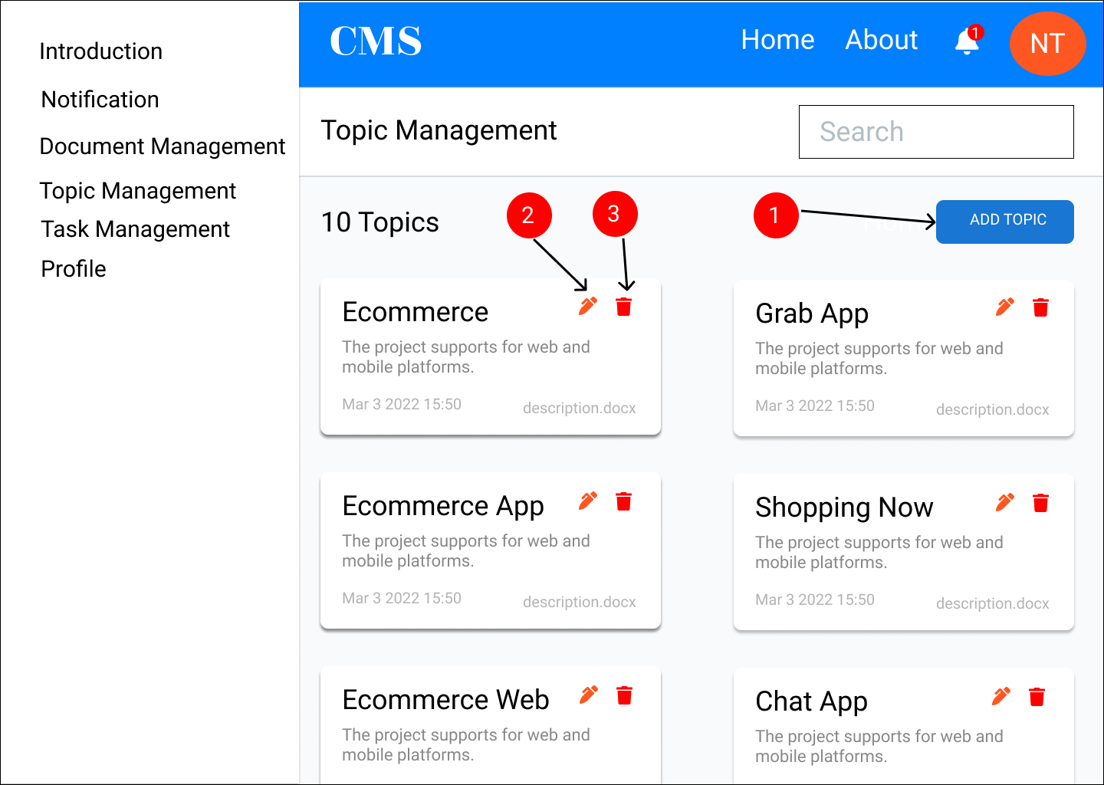

**Figure 2.20:** *Topic management.*

**Table 2.20:** *Topic management description.*

|  |  |  |  |
| --- | --- | --- | --- |
| **ID** | **Condition** | **Control Type** | **Target** |
| 1 | Click | Button | Add a new topic |
| 2 | Click | Button | Edit topic |
| 3 | Click | Button | Delete topic |

* 1. **Contribution report**

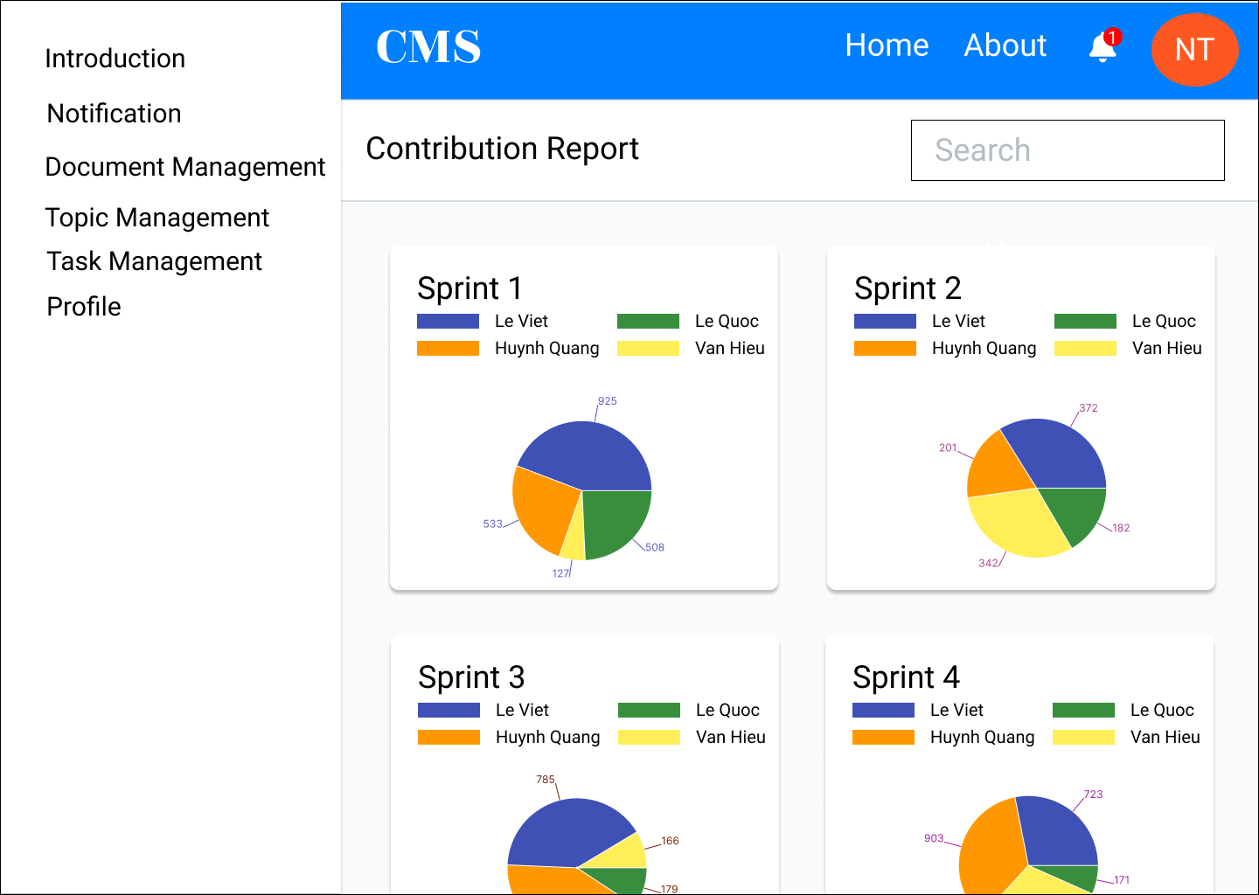

**Figure 2.21:** *Contribution report.*